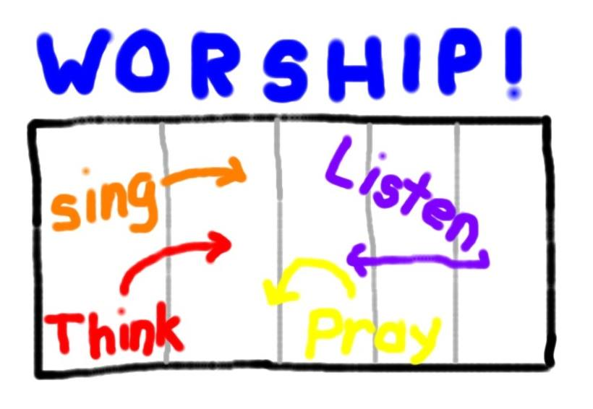

Worshiping With Children
Too often children understand worship as a long program or play which is put on by others and which they do not understand. They see their role as being quiet, patient, and wondering if the adults are right when they say “you’ll understand it one day.” A different vision can make a big difference. Children can be told that a worship service is like a soccer game. The people in the pews (including them) are the players on the field. The preachers, worship leaders, choirs and instrument players are coaches. The people “up front” are calling in plays and directions, but is the people in the pews who actually do the worshiping. The challenge for children (and all worshipers) is to get in the game rather than just sit there. For young worshipers there are four basic plays to worship:
1. Singing – We sing songs that remind us of who God is, what God does, and who we are. To hone this skill children need to learn the repeated songs so they can sing along. And, they need to be introduced to new songs with the expectation that some songs will become their favorites and others will be just there. Just like we prefer some plays but learn to play all the plays, we sing all the songs.
2. Praying – We talk to God about whatever is going on in our lives and in our world. Each of us has our own list of things to pray about each Sunday. We also hear what other worshipers are praying about and pray with them.
3. Listening – We listen to the reading of the Bible and what the preacher says about the Bible. We listen for what God might be saying to us through what we hear.
4. Thinking – We think about things that are important to us as we sing, pray and listen. If your preacher begins the sermon praying about the words of his/her mouth and the meditations of our hearts, point that prayer out. Explain that the preacher is not trying to impress us, but to give us things to think about. Note that sometimes people listen to every word a preacher says. Other times people hear something that makes them think about something else that is important to them. When this happens they think about that for a while, then tune back in to the preacher when they are done. And, occasionally people come to worship so worried about something that they spend the whole sermon time thinking about that thing. All are good ways to think in worship because sitting in the sanctuary with lots of other people thinking about God is one of the best places to think things through with God.
When singing, praying, listening, and thinking are seen as plays in the game of worship, children can be asked how they were involved in the plays of a given worship service. They can also be coached on skills for the game of worship. The youngest worshipers can do drills on finding hymns, learn the Lord’s Prayer and other repeated pieces of the worship liturgy. Parents can ask children what they heard in worship today. They can share what they thought about and ask what the child might have thought about during the sermon.
NOTE: for many adults a game is a pastime, not the center of life. Talking about worship as a game seems disrespectful. But for many children the best things in life are games. They want most to succeed at games. They learn about life by playing on teams under the leadership of coaches who want them to be able to play their best. So, seeing worship as a game makes it more interesting and calls them to participate rather than endure.

